DC Motors

A direct current (DC) motor is a fairly simple electric motor that uses electricity and a magnetic field to produce torque, which turns the motor. At its most simple, a DC motor requires two magnets of opposite polarity and an electric coil, which acts as an electromagnet. The repellent and attractive electromagnetic forces of the magnets provide the torque that causes the DC motor to turn.
Whenever a robotics hobbyist talk about making a robot, the first thing comes to his mind is making the robot move on the ground. And there are always two options in front of the designer whether to use a DC motor or a stepper motor. When it comes to speed, weight, size, cost... DC motors are always preferred over stepper motors. There are many things which you can do with your DC motor when interfaced with a microcontroller. For example you can control the speed of motor, you can control the direction of rotation, you can also do encoding of the rotation made by DC motor i.e. keeping track of how many turns are made by your motors etc. So you can see DC motors are no less than a stepper motor.
How to interface a DC motor with a microcontroller? Usually H-bridge is preferred way of interfacing a DC motor. These days many IC manufacturers have H-bridge motor drivers available in the market like L293D is most used H-Bridge driver IC. H-bridge can also be made with the help of transistors and MOSFETs etc. rather of being cheap, they only increase the size of the design board, which is sometimes not required so using a small 16 pin IC is preferred for this purpose.
Working Theory of H-Bridge:
The name "H-Bridge" is derived from the actual shape of the switching circuit which control the motion of the motor. It is also known as "Full Bridge". Basically there are four switching elements in the H-Bridge as shown in the figure below.
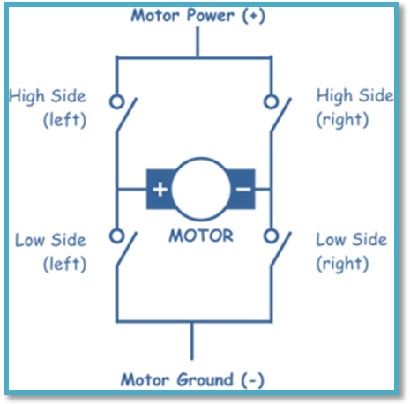
As you can see in the figure above there are four switching elements named as "High side left", "High side right", "Low side right", "Low side left". When these switches are turned on in pairs motor changes its direction accordingly. Like, if we switch on High side left and Low side right then motor rotate in forward direction, as current flows from Power supply through the motor coil goes to ground via switch low side right. This is shown in the figure below.
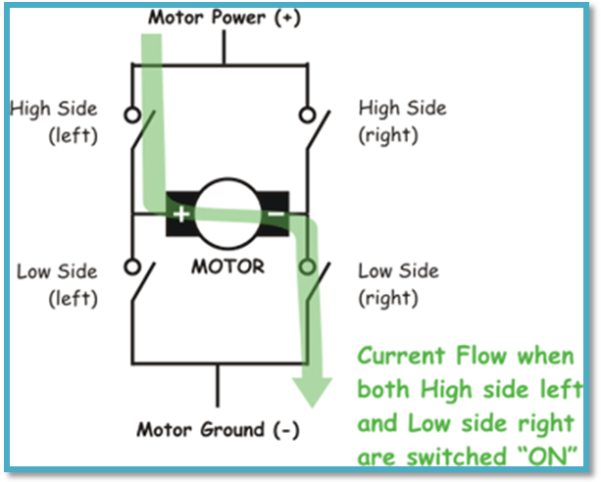
Similarly, when you switch on low side left and high side right, the current flows in opposite direction and motor rotates in backward direction. This is the basic working of H-Bridge. We can also make a small truth table according to the switching of H-Bridge explained above.
Truth Table
High Left | High Right | Low Left | Low Right | Description
On | Off | Off | On | Motor runs clockwise
Off | On | On | Off | Motor runs anti-clockwise
On | On | Off | Off | Motor stops
Off | Off | On | On | Motor stops
As already said, H-bridge can be made with the help of transistors as well as MOSFETs, the only thing is the power handling capacity of the circuit. If motors are needed to run with high current then lot of dissipation is there. So head sinks are needed to cool the circuit.
Now you might be thinking why we did not discuss the cases like High side left on and Low side left on or high side right on and low side right on. Clearly seen in the diagram, we don't want to burn our power supply by shorting them. So that is why those combinations are not discussed in the truth table.
So we have seen that using simple switching elements we can make our own H-Bridge, or other option we have is using an IC based H-bridge driver.
L293D Dual H-Bridge Motor Driver:
L293D is a dual H-Bridge motor driver, so with one IC we can interface two DC motors which can be controlled in both clockwise and counter clockwise direction and if you have motor with fix direction of motion then you can make use of all the four I/Os to connect up to four DC motors. L293D has output current of 600mA and peak output current of 1.2A per channel. Moreover for protection of circuit from back EMF output diodes are included within the IC. The output supply (VCC2) has a wide range from 4.5V to 36V, which has made L293D a best choice for DC motor driver.
Pin Diagram of L293D:
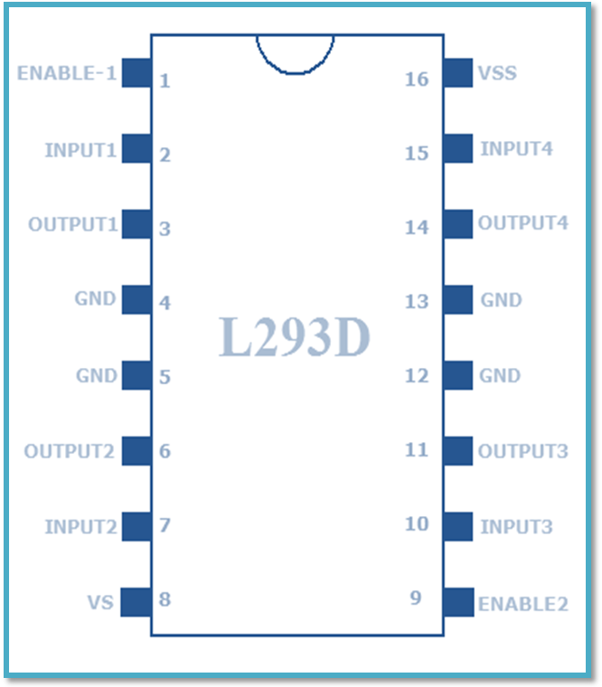
Supply voltage (Vs) is the Voltage at which we wish to drive the motor. Generally we prefer 6V for DC motor and 6 to 12V for gear motor, depending upon the rating of the motor.
Logical Supply Voltage (Vss) will decide what value of input voltage should be considered as high or low .So if we set Logical Supply Voltage equals to +5V, then -0.3V to 1.5V will be considered as Input Low Voltage and 2.3 V to 5V will be considered as Input High Voltage.
L293D has 2 Channels as follows:
- Channel 1 - Pin 1 to 8
- Channel 2 - Pin 9 to 16
Enable Pins are used to enable or to make a channel active. Enable pins are also called as Chip Inhibit Pins.
All input pins (Pin No. 2, 7, 10 and 15) of L293D IC are the output from the microcontroller and all output pins (Pin No. 3, 6,11and 14) of L293D IC goes to the input of motors.
L293D Typical Applications:
A simple schematic for interfacing a DC motor using L293D is shown below:
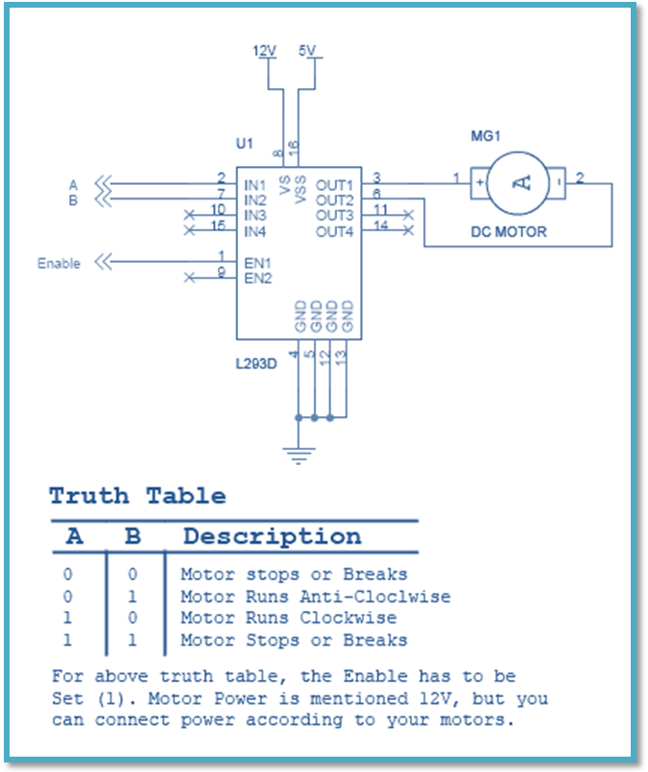
As you can see in the circuit, three pins are needed for interfacing a DC motor (A, B, Enable). If you want the o/p to be enabled completely then you can connect Enable to VCC and only 2 pins needed from controller to make the motor work.
DC MOTOR:

A DC motor is an electric motor that runs on direct current (DC) electricity.DC motors are fairly simple to understand. They are also simple to make only require a battery or dc supply to make them run.

An electric motor is a machine which converts electrical energy into mechanical energy.
Principle:
It is based on the principle that when a current-carrying conductor is placed in a magnetic field, it experiences a mechanical force whose direction is given by Fleming's Left-hand rule and whose magnitude is given by
Force, F = B I l Newton
Where B is the magnetic field in Weber/m².
I is the current in amperes and
l is the length of the coil in meter.
The force, current and the magnetic field are all in different directions.
If an Electric current flows through two copper wires that are between the poles of a magnet, an upward force will move one wire up and a downward force will move the other wire down.
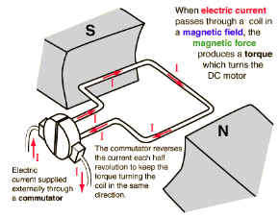 | 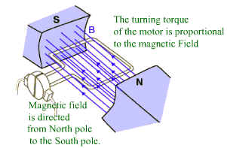
Figure 1: Force in DC Motor | Figure 2 : Magnetic Field in DC Motor
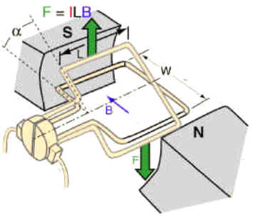
Figure 3 : Torque in DC Motor | Figure 4 : Current Flow in DC Motor
The loop can be made to spin by fixing a half circle of copper which is known as commutator, to each end of the loop. Current is passed into and out of the loop by brushes that press onto the strips. The brushes do not go round so the wire do not get twisted. This arrangement also makes sure that the current always passes down on the right and back on the left so that the rotation continues. This is how a simple Electric motor is made.

